**Test Approach:**

1. Functional and Regression testing will be performed for this application
2. Testers are responsible to perform this activity
3. Mobile and Performance testing will be out of scope
4. Test environment must be up and running
5. Verify test data required or not as a prerequisite to perform functional testing
6. Identified top 5 critical functional scenarios to test for this application
7. Reported bug for few critical scenarios with proper steps and expectations
8. Automating few scenarios if manually working as expected after automation feasibility of the functional test cases/scenarios
9. For automation, Page Object Model (POM) based framework is created with TestNG as a Unit testing library and Maven as a build management tool
10. Extent Report is used as a reporting tool for our automation tests
11. GitHub is used as a (Version Control System) VCS and the project has uploaded accordingly

**Major Functionalities Identified**

1. Register the new user

2. Login with new registered user

3. Update the user profile

4. Buggy car voting

5. Sorting column wise (Make/Mode/Rank/Votes/Engine)-ASC/DESC

**Top 5 scenarios to automated as a single scenario**

1. Verify user is able to launch the application
2. Verify user is able to complete the registration
3. Verify user is able to login to the application
4. Verify user is able to verify the profile section
5. Verify user is able to vote for a particular Car model

**High-level Defects**

**BugId-001**

1. Login “**User name”** and Login “**Password”** labels are missing in user input box beside login button in **main page**

Steps to Replicate:

1. Open the application using <https://buggy.justtestit.org/>
2. Verify user is able to enter the user name
3. Verify user is able to enter the password

**Expected**: User should be able to login after entering user name and password into correct user input boxes

**Actual**: User is unable to differentiate user id and password input box and there is only one label mentioned as ‘**Login’** which is confusing

**Screenshot**

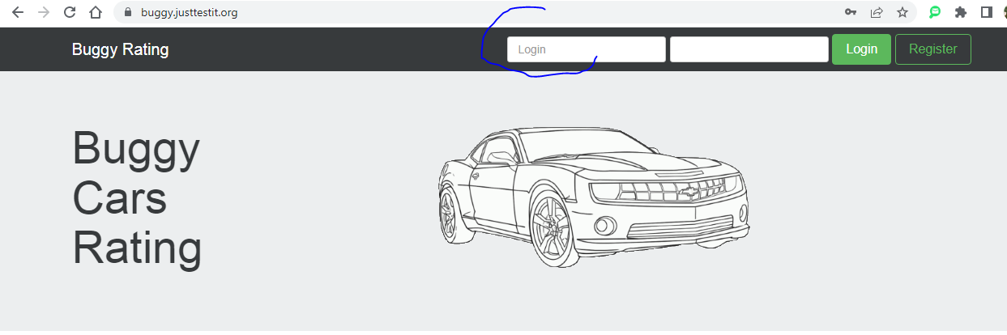

**BugId-002**

2. Login “**User name”** is wrongly showing as “**Login”** in **registration page**

Steps to Replicate:

1. Open the application using <https://buggy.justtestit.org/>
2. Click on “Register” button
3. Verify the “User name” field with label as “User name”

**Expected**: User will be able to enter their name under the textbox labeled as “User name”

**Actual**: The label of user name input box is wrongly showing as “Login”

**Screenshot**

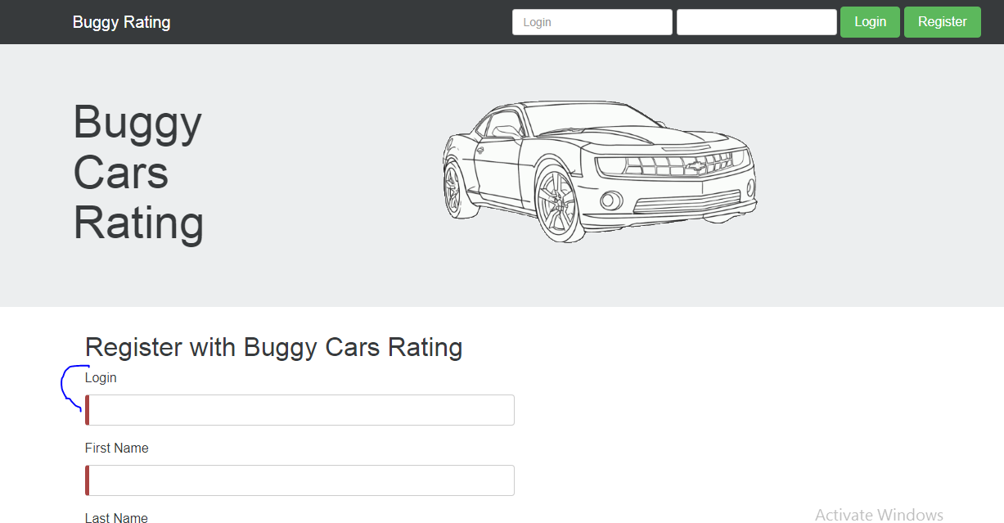

**BugId-003**

2. Login “**User name”** is wrongly showing as “**Login”** under “**Basic**” header section after clicking on user profile in **profile page**

Steps to Replicate:

1. Open the application using <https://buggy.justtestit.org/>
2. Verify user is able to complete registration successfully and generate user name and password
3. Verify user is able to enter name and password and click on Login button
4. Verify user is able to login successfully
5. Click on profile section
6. Verify user name under Basic section header

**Expected**: Proper user name should be showing up under the textbox labeled as “User name”

**Actual**: User name is showing up correctly but the label is wrongly showing as “Login”

**Screenshot**

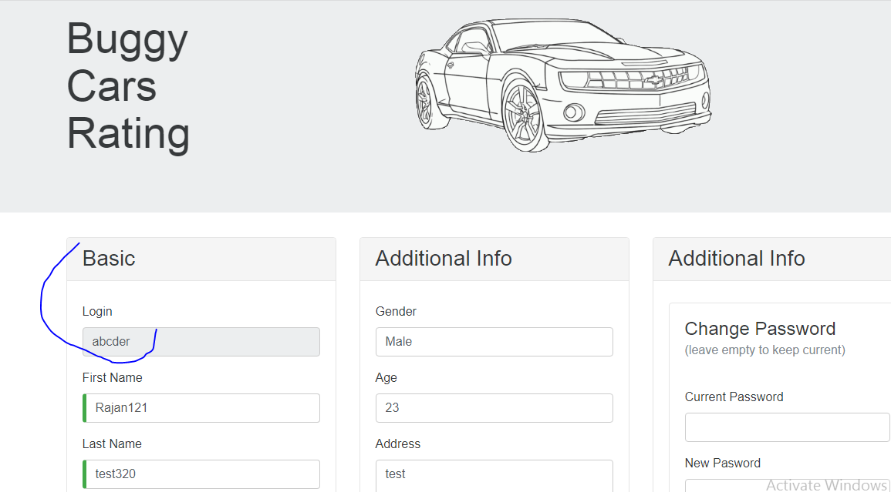

**Overall Identified Bugs / functional and layout defects**

1. After login, I click on the profile menu and clicked the logout button. Still, I can see the profile information

2. After login not navigating to home page

3. No return button to home page

4. When I click Poplar Make and I clicking Buggy Rating menu bar text, it is not navigating to home page

5. From home page I click Poplar model and navigating to respective (Lamborghini Diablo) car page. Then I click on car image it is navigating to home, but expectation is to enlarge the picture in the full screen mode. (This is occurring to any car's individual page)

6. "Overall Rating / List of all registered models" section we have options to sort the cars based on Make, Model, and other headers. If you click the header it will sort. Only one time sort is working for ascending only. It is not working for deseeding order and when you click the header multiple times sorting is not working as expected in all the pages

7. Rank and Votes columns are not sorting in descending order

8.When you navigate to any car, and I click on the car logout respective to any cars then I click on the "Buggy Rating" label on the menu. it is not working

9. Not able to create new users. That is, I have created multiple new users. but first user can login not the rest

10. While sorting first row is not sorting

11. When I click a particular car image to see the car picture in a zoom view it is not happening. Instead it going to home page

12. In the car specification page, Autor details are missing for some models which is one of the critical bug. For example, Diablo model from Popular Model section

13. The license is very old 2016 (Should be in current)

14. Picture is not loaded / missing in the 5th page of Overall Rating section

15. Engine column is missing in the “Popular Make” section

16. In the user profile section field “Gender” is accepting input which is critical

17. In the user profile section field “Age” is accepting alphanumeric input which is critical